**3.** **pielikums**  
**Ministru kabineta**  
**2023. gada 16. jūnija**  
**rīkojumam Nr.** **346**

**Model *Curriculum Vitae* for Candidates Seeking Election to the European Court of Human Rights**

**I. Personal details**   
Name, surname   
Sex   
Date and place of birth   
Nationality/ies

**II. Education and academic and other qualifications**

**III. Relevant professional activities**   
a. Description of judicial activities   
b. Description of non-judicial legal activities   
c. Description of non-legal professional activities   
(Please put in bold the post(s) held at present)

**IV. Activities and experience in the field of human rights**   
V. Public activities   
a. Public office   
b. Elected posts   
c. Posts held in a political party or movement   
(Please put in bold the post(s) held at present)

**VI. Other activities**   
a. Field   
b. Duration   
c. Functions   
(Please put in bold your current activities)

**VII. Publications and other works**   
(You may indicate the total number of books and articles published, but mention only the most important titles (maximum 10))

**VIII. Languages**   
(Requirement: an active knowledge of one of the official languages of the Council of Europe and a passive knowledge of the other)

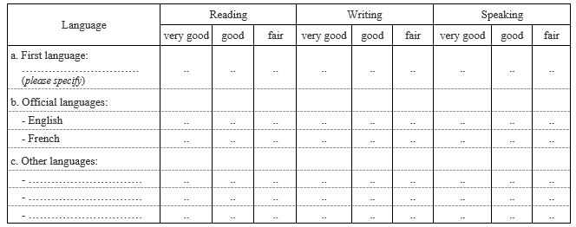

**IX. In the event that you do not meet the level of language proficiency required for the post of judge in an official working language (second), please confirm your intention to follow intensive language classes of the language concerned prior to, and if need be also at the beginning of your term of duty if elected a judge on the Court.**

**X. Other relevant information**

**XI. Please confirm that you will take up permanent residence in Strasbourg if elected a judge on the Court.**