 | EUROPEAN COMMISSION  Service for Foreign Policy Instruments  Public Diplomacy, Global Alliances and Election Observation (FPI.3)  Head of Unit

Note to Member States
Call for Candidatures for Long-Term and Sort-Term Observers
for an Election Observation Mission (EU EOM) to The Gambia 2026

The European Commission initiates the selection procedure for the positions of Long-Term and Short-Term Observers to observe the upcoming Presidential elections in the Republic of The Gambia, scheduled to take place on 05.12.2026
- Long-Term Observers
16 Long-Term Observers
Each Member State is invited to submit the following number of possible LTOs: | Up to 2
Indicative Deployment Date of LTOs | From 02.11.2026 to 12.12.2026
Availability requested for selected Observers | 41 days in The Gambia
Compulsory pre-deployment awareness training | Yes, included in the pre-deployment briefing in country
Briefing will take place upon arrival | Upon arrival in The Gambia*
Forfait (lump sum) | 300 EUR per day

* The duration and organisation of this session will be decided by the Program Manager and the Deputy Chief Observer.

2. Short-Term Observers
20 Short Term Observers (18 + 2 candidates from EU Focal Points)
Each Member State is invited to submit the following number of possible STOs: | Up to 2
Indicative Deployment Date of STOs | From 29.11.2026 to 10.12.2026
Availability requested for selected Observers | 12 days in The Gambia
Compulsory pre-deployment awareness training | Yes, included in the pre-deployment briefing in country
Briefing will take place upon arrival | 2 days upon arrival in The Gambia
Forfait (lump sum) | 260 EUR per day

The assignment length is indicative and might be modified. For all members of the mission, except for the STOs, the number of working days shall be calculated on an average of 6 working days a week (Election Day will be considered as a working day). Some exceptions will be granted by on a case-by-case basis by the European Commission Service for Foreign Policy Instruments unit FPI.3 (FPI) in cooperation with the European External Action Service division EEAS.POL.MULTILATERAL.2 (example: first week of deployment for the Implementing Partner, last week before election for the CT, LTOs…). The Deputy Chief Observer and the Implementing Partner will make sure a backup exist for all important postings.

New deadline: In order to ensure the recruitment of observers, the European Commission invites Member States to submit candidates' names via the ROSTER at the latest by Wednesday 30th September 2026 (23:59 Brussels time).

- LANGUAGE
The working and reporting languages of the mission will be English.
- IMPORTANT REMARKS
Member States should ensure a fair balance among the gender, professional and linguistic background of shortlisted candidates.
Observers would be deployed throughout the country. Observers should be willing to accept difficult living conditions when deployed in some Areas of Responsibility. It is therefore important that Observers are in excellent physical condition. Candidates with pre-existing/chronic illnesses who are at risk of developing serious complications in The Gambia should thoroughly discuss with their doctor. Travelers to The Gambia are advised to have a yellow fever vaccination certificate if arriving from countries with a risk of yellow fever transmission.
The risk of malaria and other insect bite disease (mosquitoes, flies, fleas) is high during the rainy season. All observers must abide to a careful insect bite prevention in order to minimize exposure. In particular, all observers, after checking with their physician, shall take a malaria chemoprophylaxis treatment such as Malarone (atovaquone – proguanil) or Doxycycline prior and during their deployment. While no other vaccinations are mandatory for entry into the country, candidates are strongly advised to follow the World Health Organization's recommended vaccination guidelines, which include Hepatitis A and B, Rabies, Polio, Measles, Typhoid.
- Candidate Profile
- Language proficiency: written and spoken proficiency in English (C1 level).
- Previous experience in the country and/or region or in a similar context will be considered an asset.
- Previous electoral observation experience and/or other relevant experience including electoral training, technical assistance or experience in the region in relevant fields:
  - LTO: Minimum two (2) observation missions as an observer or Core Team member (this may include EOMs organised by other organisations) or relevant electoral training (preferably by EODS/NEEDS).
- STOs: minimum one (1) observation mission as an observer or Core Team member (this may include EOMs organised by other organisations) or relevant electoral training (preferably by EODS/NEEDS) or relevant previous work experience.
Member States are invited to propose one STO without experience.
- Previous experience of work as a civilian in a large-scale international mission or in a human rights monitoring mission is an asset.
- Demonstrated commitment to democracy and human rights.
- Computer and IT (Microsoft Office Word, Excel, Access, Adobe Acrobat, Outlook, Android, internet browser and web mail software) literacy. Familiarity with use of satellite phones, GPS, BGAN, use of Signal and Microsoft Teams.
- Excellent physical conditions and good health, which can afford long working hours and potential demanding physical conditions. Candidates should consult their government's health advisories. Selected Candidates must submit health certificate in the format provided by European Commission.
- Living conditions: observers should be willing to accept very difficult living conditions when deployed in some duty stations.
- Full flexibility is required from the candidates in terms of mission timetable in case of changes and delays
Any applicant evaluated as 'Not recommended for future missions' will not be taken into account by the selection committee for a period of 5 years, starting from the 'election date' of the mission in the Roster for which the applicant was negatively evaluated.

- Selection of Successful Candidates and Information to be Provided to Shortlisted Observers
- The Commission and EEAS will proceed with the selection of observers in the framework of the criteria outlined in the European Union Council Decision “EU Guides for the Selection of the electoral observers” Council Decision 8728/99 - PESC 165 - COHOM 4 and will inform the Member States of the final list of selected observers.
- Previous evaluations during EU EOMs and EODS training sessions will also be taken into account.
- The Commission will use for the EU EOM the data already existing in the ROSTER system: https://webgate.ec.europa.eu/eom/roster/home
- Candidatures sent by email will not be taken into account.
- The tentative date by which the Commission plans to inform Member states and the selected/non-selected Observers is Friday 9 October 2026.
IMPORTANT REMARK: Applicants' references and professional experience might be checked and language knowledge tested through phone interviews by European Commission officials during the selection process.
- The Commission Invites the Member States:
- to only propose candidates certifying their full availability for the entire period of the mission; keeping in mind that the date between notification and deployment will be extremely tight.
- to ensure an appropriate balance between the observers' past professional experiences (various types of public or civilian background).
- to remind pre-selected observers to update their CV in the ROSTER before the submission of their candidatures. For the entire selection process and the preparations for fielding, the Commission will only take into consideration the data entered in the CV in the Roster (departure airport, passport data, email addresses, telephone numbers, etc.). Should a CV not include all the required information, the applicant may be rejected. Further communication by the candidate (for example concerning new departure airport, changed e-mail, etc.) will not be taken into consideration.
- to rank in each category all shortlisted observers by order of suggested preference.
- to inform the observers of the information and Terms of Reference detailed in the annex to the present Note (in particular regarding deployment dates & forfeit (lump sum).
- to inform the observers that proficiency in English may be tested through phone interviews by European Commission officials during the selection process.
- to inform observers of the security instructions and health precautions and requirements as published on the websites of their respective Ministries and Embassies. More information on health precautions and requirements will be communicated by the Implementing Partner to selected candidates at a later stage.
- to inform the observers to follow respectfully and at any time during their assignment as observers the EU Code of Conduct and its Ethical aspects for Election Observers as well as the European Commission’s, the EU EOM Core Team’s and Implementing Partner’s instructions, particularly security and safety instructions, upon deployment and throughout the mission.
IMPORTANT NOTE: failure to follow the Code of Conduct, its Ethical aspects and instructions may result in an early termination of the observer's assignment, immediate repatriation to the place of residence and non-recommendation for future EU EOMs.
- Information about the lump sum (Forfait) for Observers:
- Daily lump sums (forfait) are reimbursed to the Observers.
- The lump sum should be paid per day worked on the EOM, including rest days in-country.
- Travelling days for mobilisation and de-mobilisation of Observers will be eligible for the payment of the lump sum, as long as Observers are spending the night outside of their place of residence.
- Travelling days for demobilisation of Observers without spending the night outside their place of residence, the lump sum will be reduced to 30%.
- The following rules will apply, from the day of mobilisation until the day of demobilisation, including for travelling days:
  - In the event that full board accommodation (i.e. all meals included) is provided by the EU EOM, the lump sum will be reduced to 30%. This rate also applies in the case of night flights.
  - In the exceptional case that accommodation without breakfast is provided, the lump sum will be reduced to 35%.
  - In case that meals (but no accommodation) are provided, the lump sum will be reduced by 10% for each dinner, 10% for each lunch and 5% for each breakfast offered.
  - If only accommodation, including breakfast, is provided, the lump sum received will be reduced to 50% of the maximum daily rate.
  - If the accommodation without meals is provided, the lump sum will be reduced to 55%.
  - If the lunch and dinner are provided the per diem will be reduced to 80%.

Per diem calculation - LTOs/STOs
Accommodation | Breakfast | Lunch | Dinner | Total
Provided | Provided | Provided | Provided | 30%
Provided | - | Provided | Provided | 35%
Provided | Provided | - | - | 50%
Provided | - | - | - | 55%
- | Provided | Provided | Provided | 75%
- | - | Provided | Provided | 80%
Public transportation from the place of residence (as recorded in the EOM Roster at the time of the submission of the application) to the closest or economically most advantageous airport (and back) will be reimbursed, on top of the lump sum received. Taxi fare can be eligible (without the prior approval from Commission) only in two proven circumstances:

- from the residence to or from the nearest bus/train station, if such transport is needed between residence and airport.
- from the residence to the airport (and back to residence from the airport) in proven absence of the public transport (e.g.: early or late flights).

(e-signed)
Irène MINGASSON

ANNEXES:

- Code of Conduct
- Fit to Work certificate
- Privacy statement
- Ethical Guidelines (see attached document)
- Observers' Terms of Reference (see attached document)

Council Decision 9262/98 – PESC 157 – COHOM 6
GUIDELINES - EU POLICY ON ELECTORAL OBSERVATION

"Code of Conduct"
The following guidelines will apply to nationals of any country participating in EU observation missions decided by the EU unless specifically agreed otherwise. The guidelines will not apply to EU nationals participating in e.g., OSCE or UN missions, in which case those organisation’s own codes will apply.
All official EU observers should adhere to the following guidelines:
- Respect the laws of the land. Observers enjoy no special immunities as an international observer, unless the host country so provides;
- Observers will participate in all pre-election briefings with their supervising officers;
- Observers will be subject to the direction and management of the observer team leadership, carrying out their written terms of reference and covering the geographical schedules specified by team leaders;
- Observers should be aware of the presence of other electoral monitoring teams, and liaise with them under the direction of the leader of the EU observer team;
- Observers will carry prescribed identification issued by the host government or election commission, and will identify themselves to any interested authority upon request;
- Observers shall maintain strict impartiality in the conduct of their duties, and shall at no time express any bias or preference in relation to national authorities, parties, candidates, or with reference to any issues in contention in the election process;
- Observers will not display or wear any partisan symbols, colours or banners;
- Observers will undertake their duties in an unobtrusive manner, and will not disrupt or interfere with the election process, polling day procedures, or the vote count,
- Observers may bring irregularities to the attention of the election officials, but will not give instructions or countermand decisions of the election officials;
- Observers will base all conclusions on well documented, factual, and verifiable evidence, and will keep a record of the polling stations and other relevant places that they visit;
- Observers will refrain from making any personal or premature comments about their observations to the media or any other interested persons, but should provide, through a designated liaison officer or spokesperson, general information about the nature of their activities as observers;
- Observers will participate in post-election debriefings with their supervising officers and will contribute fully towards appropriate EU reports on the elections monitored;
- Observers must comply with all national laws and regulations. Where these limit freedom of assembly or movement about the country, they must note where such rules prevent them from carrying out their duties;
- At all times during the mission, including during private time away from work, each election observer should behave blamelessly, exercise sound judgement, and observe the highest level of personal discretion."
"…
ANNEX I
FIT TO WORK CERTIFICATE
Name & Surname:
Date of Birth: | ID/Passport No:

Please provide details/numbers for: | Blood type:  Blood pressure:  Pulse:  BMI:
Electrocardiogram (ECG)  For applicants over 45 years | Please provide information here:
Other comments | Please state comments here:

On the basis of the signed Medical Declaration [ANNEX I] and the medical examination which I carried out on ____/____/_________, hereby I certify that the above-mentioned person has been found to be in good health, without any medical limitations and therefore medically fit to travel and work abroad for an international mission, possibly in a post-conflict environment, that may present the following characteristics:

- Tropical weather conditions (high temperatures/humidity)
- Cold dry weather conditions
- High altitude
- Work under stressful situations which may involve long working hours
- Mosquito borne diseases
- Water-borne diseases
- Limited dietary choices
- Basic amenities available
Doctor’ Name & Surname:
Signature & Stamp:

Date & Place:
Email: | Tel:
ANNEX II
MEDICAL DECLARATION
[to be filled by the involved person]

Do you suffer from or have you ever suffered from, had symptoms of, been examined for or been treated for any of the following ailments, or anything related to them? Consider the examples as help - they do not cover all conditions. Any other symptoms or ailments must also be stated, and a clarification and further details should be written on the last page.

Diabetes, metabolic diseases, respiratory diseases, gastrointestinal diseases, and diseases of the musculoskeletal system | If yes; what and when:  What was the outcome of the treatment?  Is the treatment ongoing, completed or recurrent?
Cardiac and circulatory diseases  Blood clots, pain/tightness in the chest, high blood pressure, varicose veins, phlebitis, swollen ankles, heart rhythm disorders, pacemaker, elevated cholesterol. Other cardiovascular disorders | Yes: | No:
If yes; what and when:

What was the outcome of the treatment?

Is the treatment ongoing, completed or recurrent?

Cancer, other tumors/growths, immune system-related disorders  Any type of cancer or cancer precursor/suspected cancer. Polyps in the bowel, benign tumors/growths | Yes: | No:
If yes; what and when:

What was the outcome of the treatment?

Is the treatment ongoing, completed or recurrent?

Neurological disorders  Epilepsy, migraine and headache disorders, multiple sclerosis, stroke, alcohol-related disorders, dementia, brain injury, infections and genetic diseases, Parkinson’s disease, chronic pain and other neurological | Yes: | No:
If yes; what and when:

What was the outcome of the treatment ?

Is the treatment ongoing, completed or recurrent?

Psychiatric and behavioral disorders  Nervousness, anxiety, psychosis, depression, mania, insomnia, or disorders related to addiction to alcohol or drugs, or other addictions. Dementia. Developmental and behavioral disorders, compulsive behaviors (ADHD, OCD, etc.). Other psychiatric disorders and symptoms? | Yes: |  | No:
If yes; what and when:

What was the outcome of the treatment ?

Is the treatment ongoing, completed or recurrent?

Alcohol and intoxicating substances/narcotics(?)  Have you at any time for a period of more than six months, consumed more than 14 units of alcohol (men)/ 7 units of alcohol (women) per week?  Have you at any time for a period of more than six months used intoxicating substances? | Yes: |  | No:
Allergies  Drugs, Foods, Other | Yes: |  | No:
Allergies  Drugs, Foods, Other | If yes, what kind?
Do you presently take any kind of medicine | Yes: |  | No:
Do you presently take any kind of medicine | If yes, what kind of medicine and for what reason:
Previous hospital admissions | Yes: |  | No:
Previous hospital admissions | If yes; for what and when?  If yes, is the treatment ongoing or are you cured?
Other remarks | Please state comments here:

I, the undersigned, hereby declare that:

- All information provided in this Medical Declaration Form is correct to the best of my knowledge, and that no information concerning my past or present health has been withheld;
- This medical declaration has been provided to my physician prior to obtaining the Fit to Work Certificate;
- In the event of apparent change of my medical condition, I understand that I am obliged to update my fit-to-work certificate.

Name & Surname:
Date of Birth: | ID/Passport No:
Signature:

Date and Place:

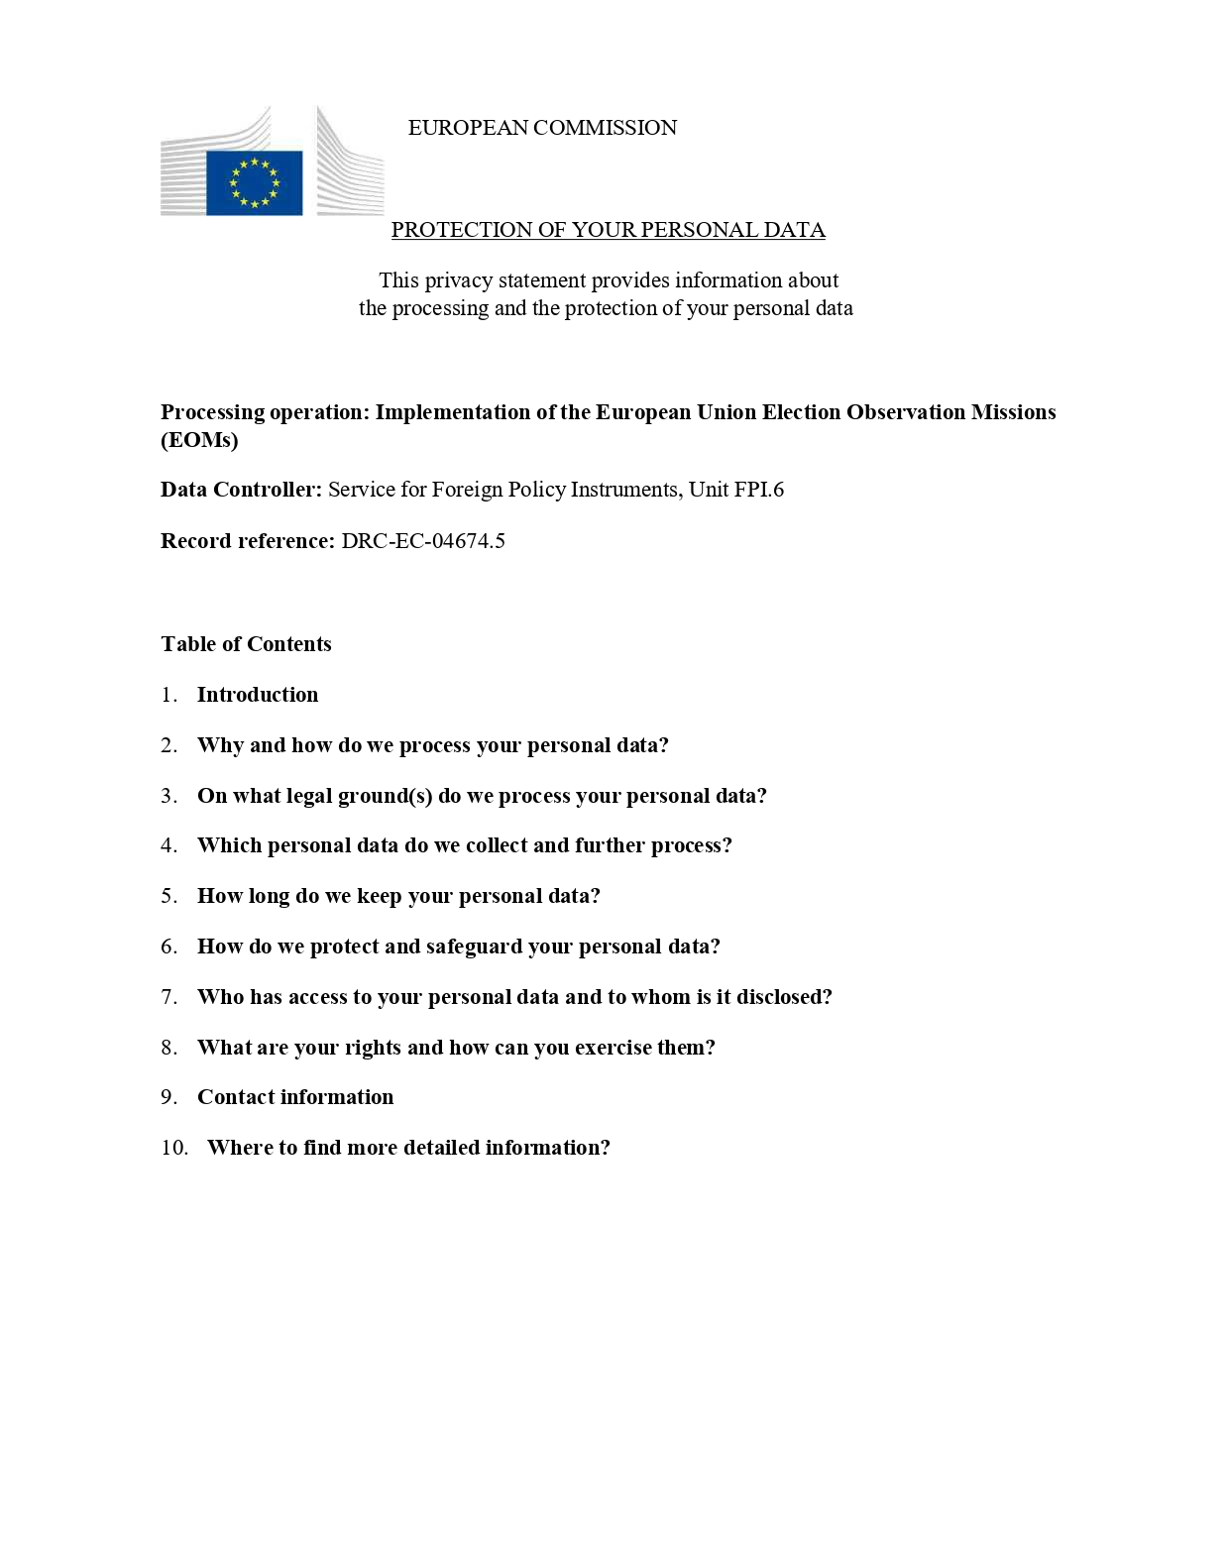

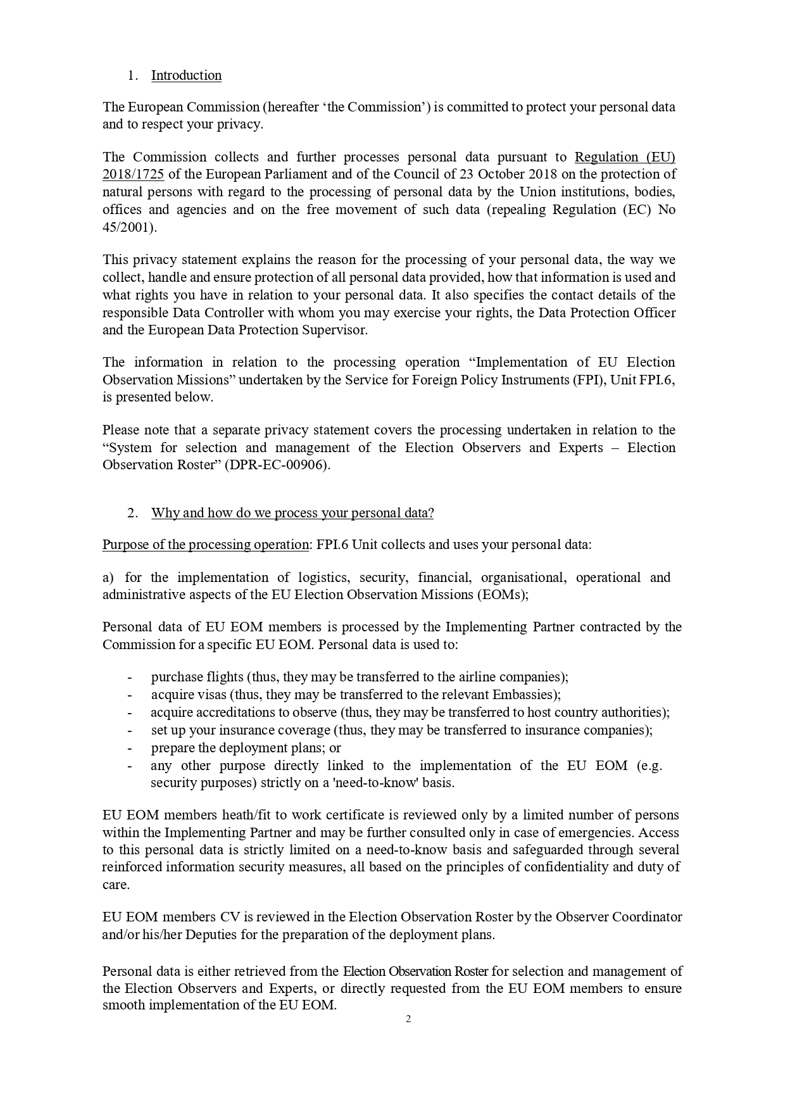
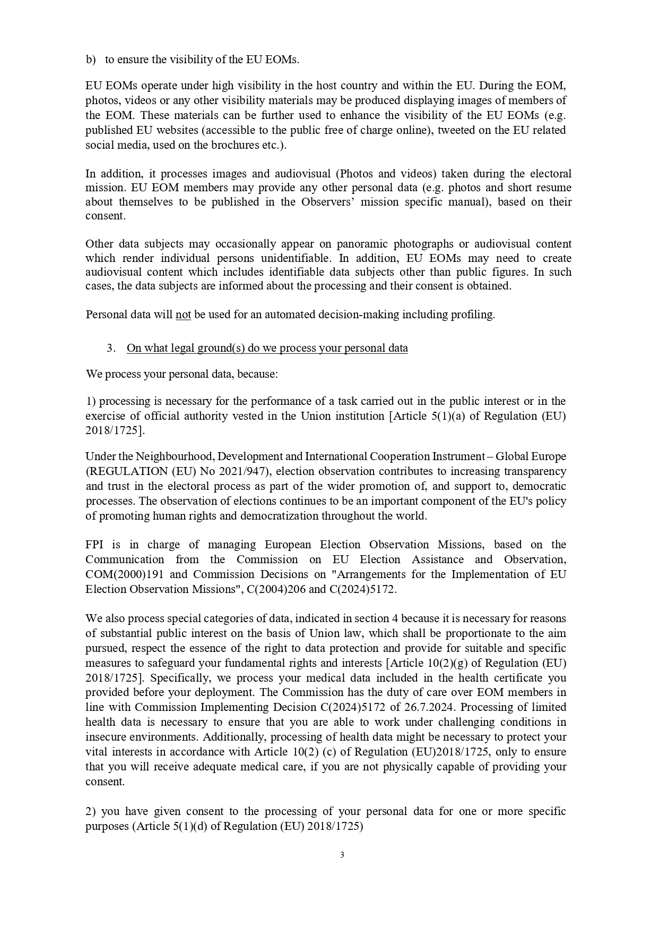
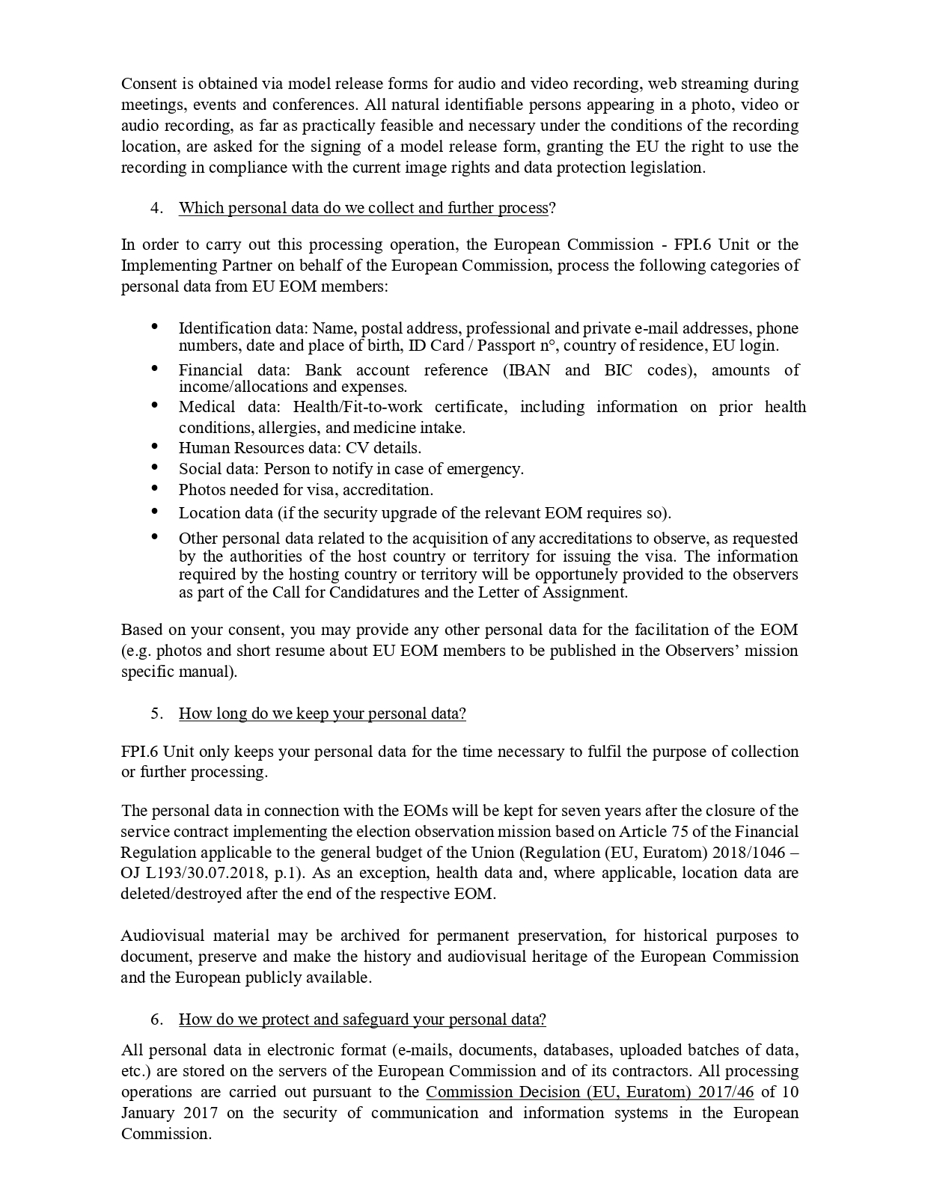

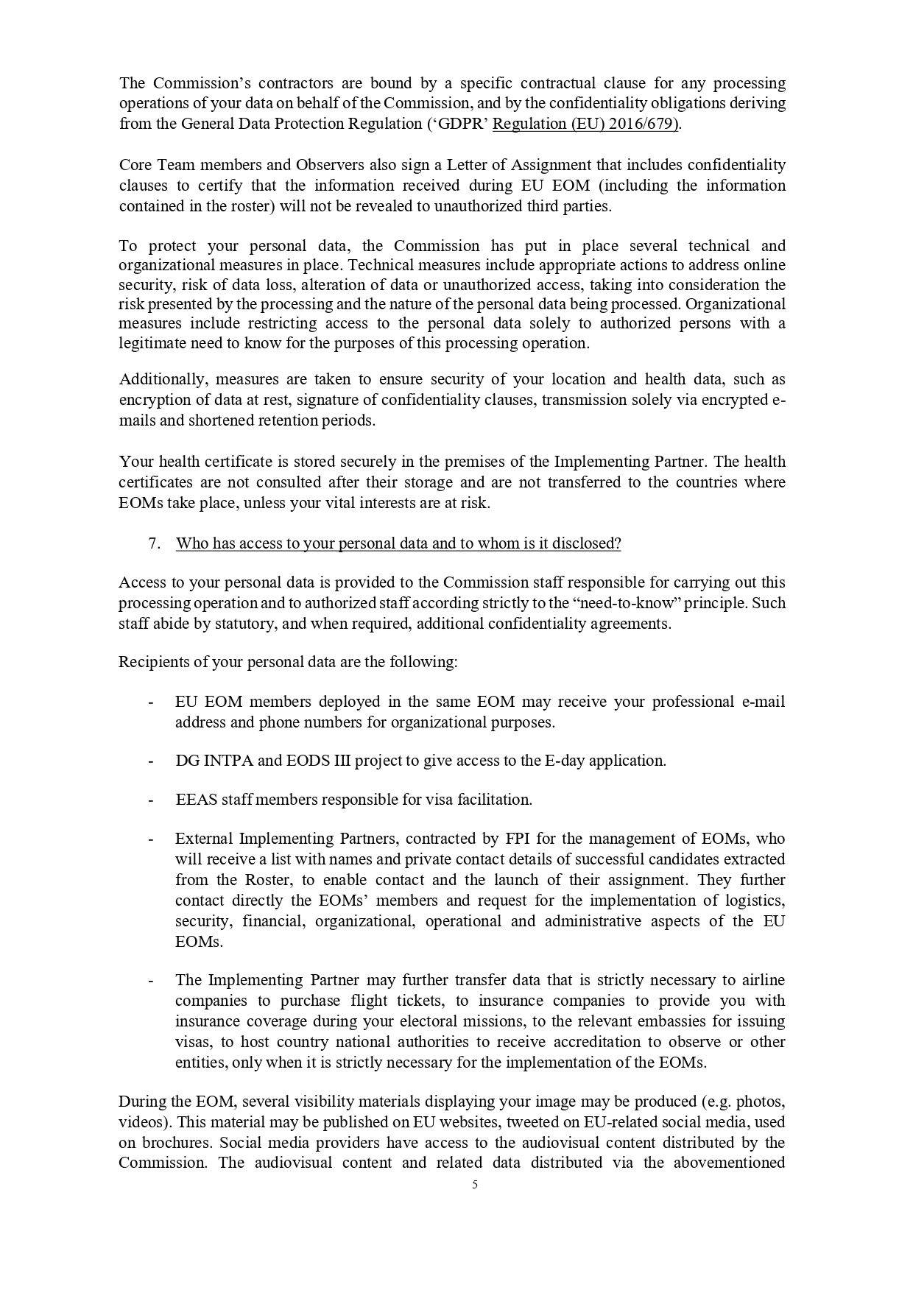
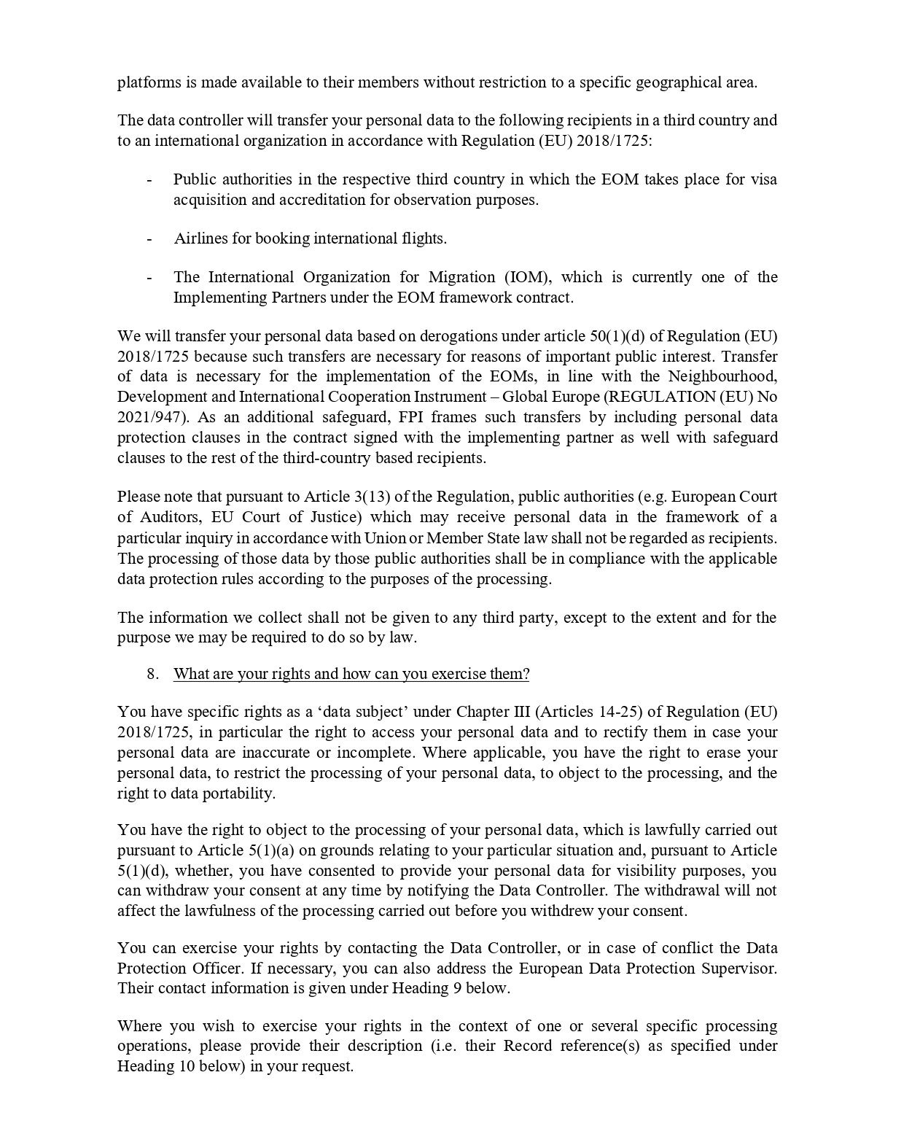

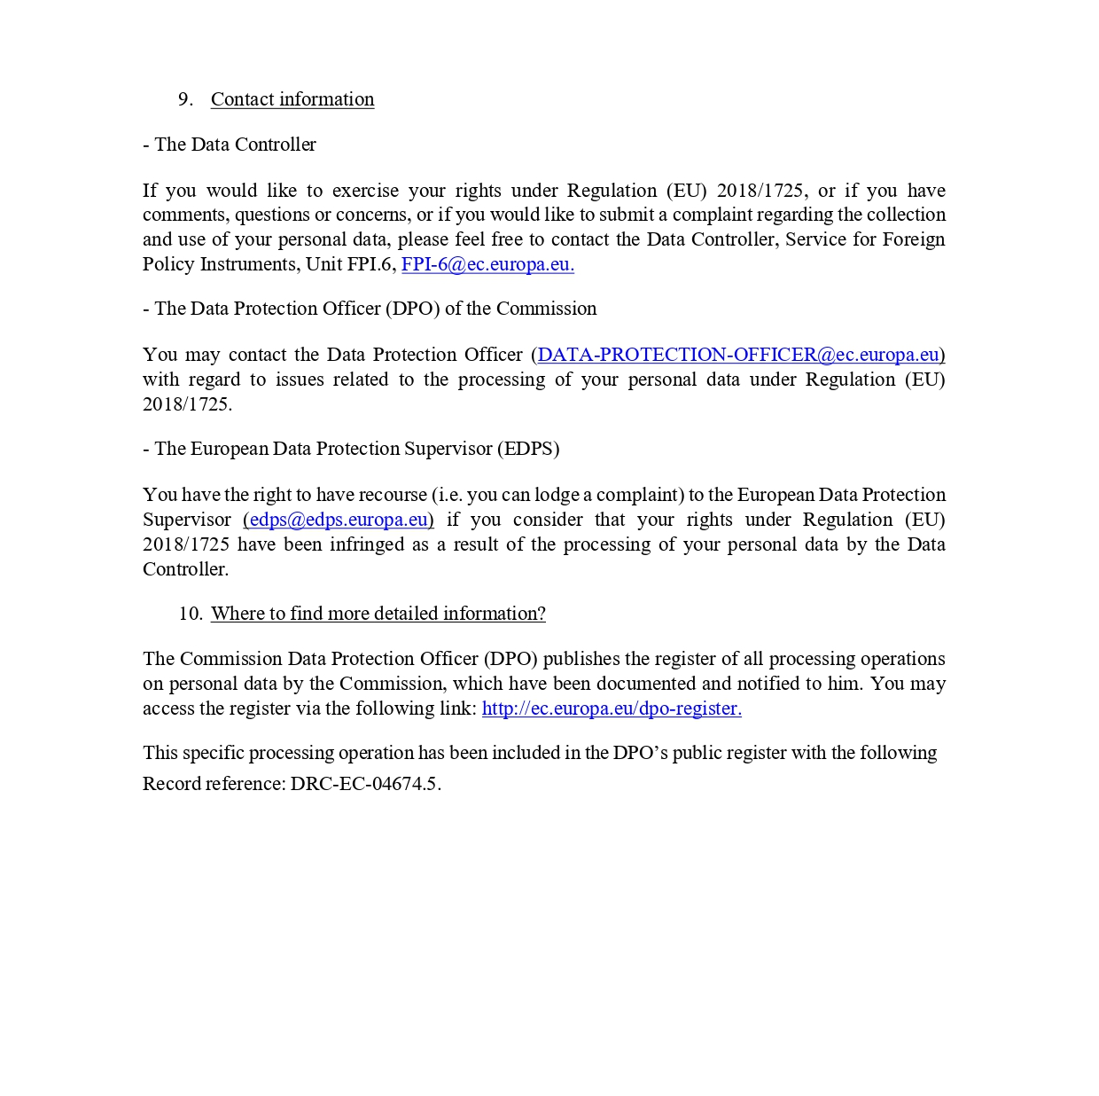
The online version of the Privacy statement can be found here: EOM Implementation Privacy Statement 2025

Depending on the developments on electoral and security situation, the decision may be revised.
According to the procedures set out the Commission implementing decision C(2024)5172 of 26.07.2024 adopting the Implementing Arrangements for Election Observation Missions repealing and replacing Commission Implementing Decision C(2014)7782.
Depending on the developments on electoral and security situation, the decision may be revised
According to the procedures set out the Commission implementing decision C(2024) 5172 of 26.07.2024 adopting the Implementing Arrangements for Election Observation Missions repealing and replacing Commission Implementing Decision C(2014)7782.
Level C1 according to the Council of Europe languages levels available at Global scale - Common Reference levels - Common European Framework of Reference for Languages (CEFR)

